**PowerShell and Windows Firewall**

This Document will walk through the process of Importing server manager into PowerShell, Installing Internet Information services and turning on the Firewall and opening up ports 80 and 443 for Transmission Control Protocol in the Microsoft Official Academic Course training program, lab 2 for Windows Server .

This document assumes that the user already knows how to get into the MOAC labs and opening Windows PowerShell ISE and running commands.

1:Open Windows PowerShell ISE:

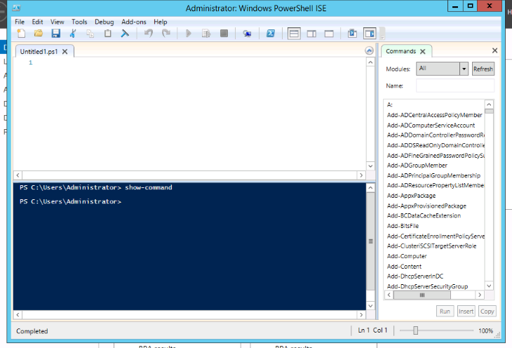

2: Import Server Manager

Command: Import-Module servermanager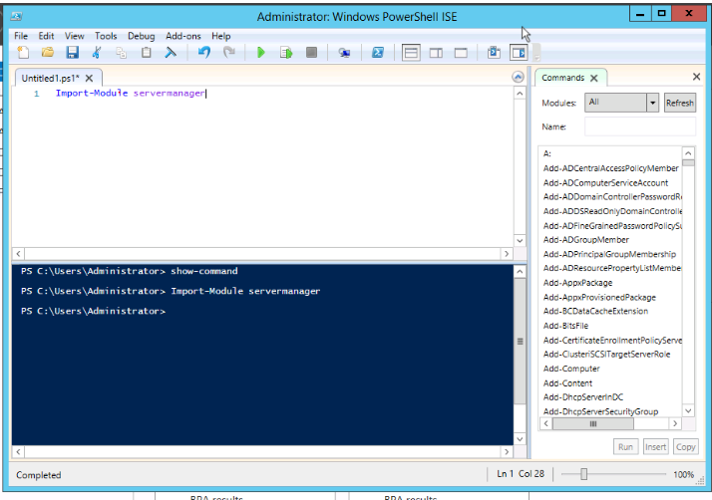

3: Install Internet Information Services (IIS)

Command: Install-WindowsFeature Web-Server,Web-Common-Http, Web-Mgmt-Console -Restart

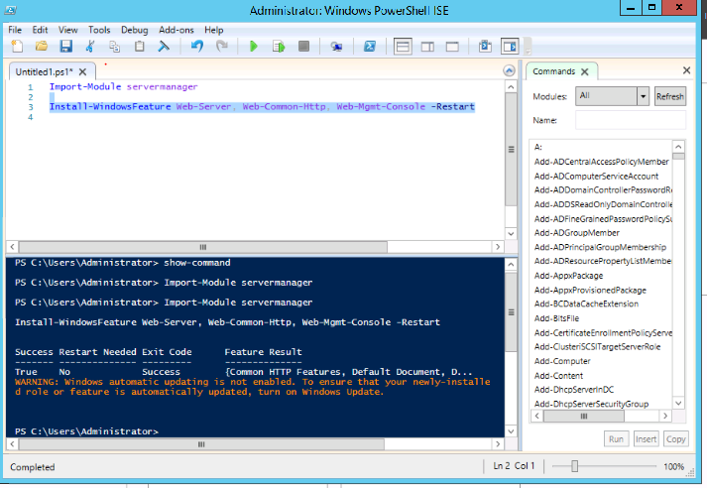

4: Turn on Windows FirewaNell

Command: Set-NetFirewallProfile -Profile Domain, Public, Private -Enabled True

Note: Windows Firewall is on by Default. Note: Using the False command in place of True will turn off the Firewall

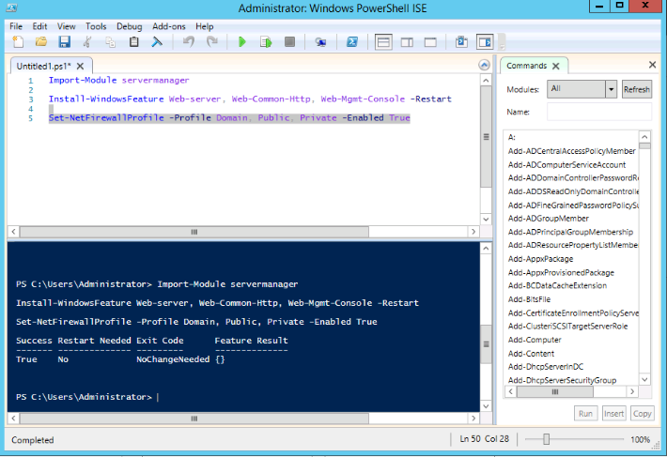

5: Turn on Port 80

Command: New-NetFirewallRule -DisplayName AllowPort80 -Direction Inbound -LocalPort 80 -Protocol TCP -Action Allow

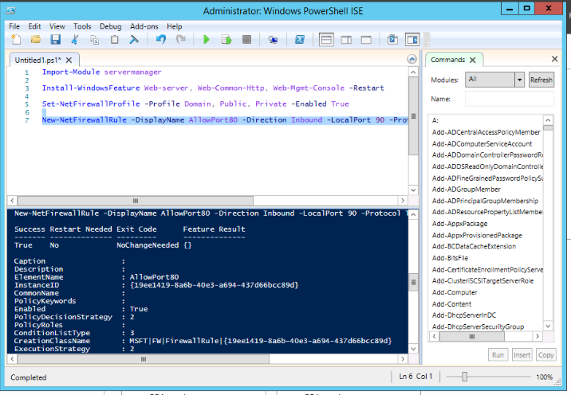

6: Turn on Port 443

Command: New-NetFirewallRule -DisplayName AllowPort443 -Direction Inbound -LocalPort 443 Protocol TCP -Action Allow

